

**TRIBHUVAN UNIVERSITY**

**Faculty of Humanities and Social Sciences**

**One Stop for Trekking Solution**

**A Project Report**

Submitted to

Department of Computer Application

JANAMAITRI MULTIPLE CAMPUS

**In partial fulfillment of the requirements for the Bachelor degree in BCA (Bachelors in Computer Application)**

Submitted by

**Laxmi Thami**

**(Registration No: 6-2-263-16-2021)**

**Siddhartha Shakya**

**(Registration No: 6-2-263-29-2021)**

Under the Supervision of

**Kamal Tamrakar**

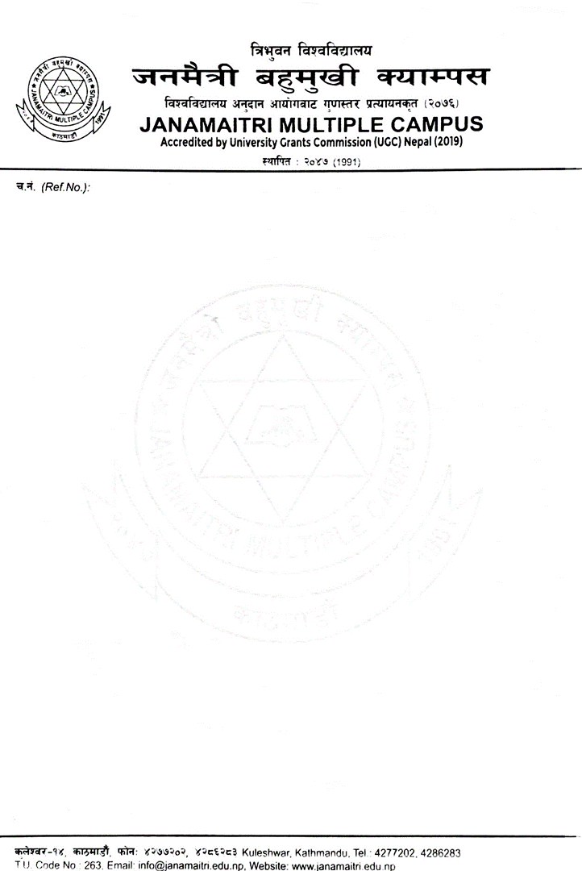

# SUPERVISOR’S RECOMMENDATION

I hereby recommend that this project has been prepared under my supervision by **Laxmi Thami** **(Registration No: 6-2-263-16-2021)** and **Siddhartha shakya (Registration No: 6-2-263-29-2021)** entitled " **One Stop for Trekking Solution"** in partial fulfillment of the requirements for the Bachelor's degree of BCA (Bachelor of Computer Application) is recommended for the final evaluation.

**………………………………..**

**Kamal Tamrakar**

Supervisor



# LETTER OF APPROVAL

This is to certify that this project prepared by **Laxmi Thami (Registration No: 6-2-263-16-2021)** and **Siddhartha shakya (Registration No: 6-2-263-29-2021)** entitled " **One Stop for Trekking Solution"** in partial fulfillment of the requirements for the bachelor's degree of BCA (Bachelor of Computer Application) has been evaluated. In our opinion it is satisfactory in the scope and quality as a project for the required degree.

|  |  |
| --- | --- |
| **Signature of Supervisor**  **……………………………..**  Kamal Tamrakar  (Supervisor) | **Signature of HOD/ Coordinator**  **………………………………**  Kamal Tamrakar  (HOD/Coordinator) |
| **Signature of Internal Examiner**  **………………………………..**  Internal Examiner | **Signature of External Examiner**  **………………………………..**  External Examiner |

# ABSTRACT

One Stop Trekking Solution is a comprehensive and user-friendly platform dedicated to catering to the needs of trekking enthusiasts, adventure seekers, and outdoor enthusiasts in Nepal. This website aims to provide a one-stop solution for all trekking-related requirements, offering a wide range of premium trekking gear, equipment, and services. Everything a hiker might possibly need is available, including clothing, boots, sleeping bags, tents and accessories.

This site stands out as a premier platform, not only offering top-notch trekking gear but also providing a holistic experience for outdoor enthusiasts in Nepal. Whether customers are gearing up for their next trek or seeking expert advice, this website serves as the go-to destination for all things related to trekking in the breathtaking landscapes of Nepal.

Also integrating a blog system into a trekking business platform in Nepal offers numerous benefits. The blog can provide informative content about trekking routes, safety guidelines, and gear recommendations, attracting and engaging users. It becomes a platform for trekkers to share their experiences and tips, fostering a sense of community. By featuring local culture, festivals, and traditions, the blog establishes a connection between trekkers and the unique aspects of Nepal.

# ACKNOWLEDGEMENT

We extend our sincere gratitude to all those who contributed to the development of this project. First and foremost, we express our heartfelt thanks to the Department of Bachelors of Computer Applications for their indispensable support and resources, without which this project would not have been possible. We also acknowledge the invaluable guidance and mentorship provided by **Mr. Kamal Tamrakar** throughout the duration of this project. His expertise and insights have been instrumental in shaping our approach and achieving our objectives. Additionally, we appreciate the collaboration, dedication, and hard work of each team member. Our combined efforts have been crucial in bringing this project to fruition.

Furthermore, the authors would like to express their sincere gratitude to **Kamal Tamrakar**, Head of Department of BCA and BICT at Janamaitri Multiple Campus, for his unwavering support, guidance, and valuable insights during the conceptualization of this project. His leadership and encouragement were instrumental in shaping the direction of our work.

Special thanks are extended to **Abita kunwar** Madam for her expertise and assistance in database management and entity-relationship modeling, significantly enhancing the technical aspects of our project.

Additionally, we acknowledge **Subigya Ojha** Madam for her creative insights and contributions to the design elements of our platform. Her expertise in designing played a crucial role in making the learning environment interactive and visually appealing. Specifically, her assistance during the creation of the Data Flow Diagram (DFD), system layout, and system design has been invaluable.

This work would not have been possible without the collaborative efforts and support of these individuals. Their contributions have played a pivotal role in the successful formulation of this proposal and will undoubtedly impact the success of the subsequent project

# List of Figures

Figure 1: Gantt chart 7

Figure 2: ER Diagram 8

Figure 3: DFD Level 0 9

Figure 4: DFD Level 1 9

Figure 5: Clint Server Architecture 10

Figure 6: Architectural Design 11

Figure 7: Database Schema 13

# Abbreviation

CRUD: Create, Read, Update, Delete

DFD: Data Flow Diagram

ER Diagram: Entity Relation Diagram

HTML: Hypertext Markup Language

**Table of Contents**

SUPERVISOR’S RECOMMENDATION i

LETTER OF APPROVAL ii

ABSTRACT iii

ACKNOWLEDGEMENT iv

List of Figures v

Abbreviation vi

Chapter 1: INTRODUCTION 1

1.1 Introduction 1

1.2 Problem Statement 1

1.2 Objectives 2

1.4 Scope 2

1.5 Limitations 2

1.6 Report Organization 2

Chapter 2: BACKGROUND STUDY AND LITERATURE REVIEW 4

2.1 Background Study 4

2.2 Literature Review 4

Chapter 3: SYSTEM ANYLYSIS AND DESIGN 5

3.1 System Analysis 5

3.2 Requirements Analysis 5

A. Feasibility Study 5

3.2 System Design 10

Chapter 4: IMPLEMENTATION AND TESTING 17

4.1 Implementation 17

4.1.2 Implementation Details of Modules (Description of procedures/functions) 19

4.2 Testing 20

4.2.1 Test Case for Unit Testing 20

Chapter 5: CONCLUSION AND RECOMENDATION 21

5.1 Lesson Learnt/ Outcome 21

5.2 Conclusion 21

5.3 Future Recommendations 21

Reference 23

# Chapter 1: INTRODUCTION

## Introduction

"One Stop for Trekking Solution" are ambitious projects aimed at providing outdoor enthusiasts with a comprehensive and seamless platform for purchasing high-quality trekking equipment. Our goal is to offer convenience, expertise, and reliability by sourcing a diverse range of products, including Nepali-made gear known for its quality craftsmanship and durability. Through user-friendly interfaces and secure transactions, we aim to cater to the diverse needs of trekkers, both locally and internationally. This proposal outlines our commitment to delivering a superior shopping experience while promoting Nepali craftsmanship on a global scale.

## 1.2 Problem Statement

Despite Nepal's reputation for hosting some of the world's most awe-inspiring treks, such as the legendary Everest Base Camp and Annapurna Circuit, trekkers frequently encounter challenges in accessing reliable information, acquiring suitable gear, and experiencing authentic local culture. Existing platforms often lack specialization in Nepal and overlook its unique trekking culture. Our project, One Stop for Trekking Solution, aims to address these issues by offering curated gear selections suited to Nepal's diverse terrains, providing personalized recommendations tailored to user preferences, and promoting cultural immersion opportunities to foster responsible tourism and support local communities.

## **Objectives**

* Establish an online platform that specializes in offering Nepali-made trekking equipment.
* Emphasize quality, affordability, and accessibility in the selection of products and Promote Nepali craftsmanship and support local artisans.

## **1.4 Scope**

* Dependency on third-party suppliers and logistics may lead to delays.
* Security vulnerabilities in online transactions.
* Competition from established offline and online retailers.

1.5 Limitations

* Dependency on Third-Party Suppliers and Logistics
* Security Vulnerabilities in Online Transactions

## 1.6 Report Organization

This is the report organization for the web application titled "One Stop for Trekking Solution" which includes charts/ diagrams to illustrate the system architecture and design. Furthermore, it contains information regarding the tools and technologies used to build the system.

**Outline of the Report**

|  |  |
| --- | --- |
| Introduction | * Introduction * Problem Statement * Objectives * Scope and Limitation * Report Organization |
| Requirement and Feasibility analysis | * Background Study * Literature Review |
| Methodology | * Requirement Analysis * Feasibility Analysis * System Design |
| Implementation and Testing | * Tools and Technology * Test Cases |
| Conclusion and Future  Recommendations | * Lesson Learnt * Conclusion |

# Chapter 2: BACKGROUND STUDY AND LITERATURE REVIEW

## 2.1 Background Study

E-commerce has significantly transformed how businesses operate, providing an online platform for selling products and services. In Nepal's trekking industry, e-commerce enables the distribution of specialized trekking gear to a global audience. Nepal, famous for its trekking routes like Everest Base Camp and Annapurna Circuit, relies heavily on tourism, with trekking being a major economic contributor. Supporting local artisans who produce high-quality trekking gear promotes cultural heritage and strengthens the local economy. Modern e-commerce platforms feature secure payment gateways, user-friendly interfaces, and efficient inventory management systems. Integrating digital marketing strategies such as SEO, social media marketing, and content marketing enhances the platform's visibility and customer reach. Key concepts include user interface (UI) and user experience (UX) design, backend and frontend development, secure payment gateways, and content management systems (CMS). SEO is crucial for driving organic traffic, while community engagement through blogs and social media fosters user loyalty and trust. This background study establishes a foundation for developing a comprehensive e-commerce platform for trekking gear, integrating local craftsmanship with advanced e-commerce features and marketing strategies.

### 2.2 Literature Review

Our literature review encompassed an in-depth exploration of various online platforms and websites to garner insights into the landscape of trekking equipment sales in Nepal. Notable platforms such as trekkinggearnepal.com, parikramatreks.com, insidehimalayas.com, and trekkingtrail.com provided invaluable data concerning product diversity, pricing strategies, and consumer preferences prevalent within the Nepalese market. By meticulously analyzing these platforms, we were able to identify scope for improvement, pinpoint potential mistakes, and ascertain prevailing price trends, thereby enriching our understanding of the market dynamics.

Furthermore, our review extended beyond domestic boundaries to include global travel websites, offering valuable insights into international trends and customer expectations within the trekking equipment industry. This broader perspective allowed us to discern emerging patterns and preferences that could potentially influence our project's success.

Moreover, delving into prominent online marketplaces such as Daraz, dolpo.com.np, mtnoutdoors.com.np, and Nepal Adventure Team Pvt. Ltd. provided invaluable firsthand insights into the current market offerings and pricing trends. By scrutinizing these platforms, we were able to glean crucial information regarding competitor strategies, consumer behavior, and emerging market trends.

# Chapter 3: SYSTEM ANYLYSIS AND DESIGN

## 3.1 System Analysis

When developing the website, we have followed the waterfall Model. Because this project has clear objectives, detailed documentation, and well-understood technology.

### Requirements Analysis

We have analyzed and studied various similar sites such as trekkinggearnepal.com, parikramatreks.com, insidehimalayas.com and gathered many strengths and shortcoming,

to make our website stand out. Its various functional and non-functional requirements are shown below.

**Functional Requirements**

* Feature and promote local trekking gear brands and products.
* Implementation of blog feature highlighting Nepali landscapes and terrains
* Optimize the web application for users with varying internet speeds, especially in remote trekking regions.
* Integration with local payment gateways that are commonly used in Nepal.

**Non-Functional Requirements**

* To provide a seamless user experience, response times for search queries and page loading should be minimized.
* With clear labeling and directions, the user interface should be simple to use and intuitive.
* Sensitive information, such user passwords, should be protected with data encryption.
* The website needs to be built with ease of scalability in mind, able to handle a rising number of users and products.

## Feasibility Study

1. **Technical Feasibility**

**Languages:** HTML and CSS is used main programming languages. These languages allow us to create extremely responsive, flexible, and interactive website.

**Database:** Since MySQL offers a scalable and dependable option for storing data about various hiking equipment, we will utilize it as the backend database management system.

1. **Operational Feasibility**

**User Adoption:** Our One Stop for trekking solution is likely to gain a wider adoption as one stop for buying various trekking goods and learn about diverse Nepali culture.

**Integration with Existing Systems:** As our web application is developed utilizing fundamental languages such as HTML, CSS, for frontend, alongside the usage of PHP for server-side operations, it enables seamless integration with college website existing systems.

1. **Economic Feasibility**

The costs of growth is not taken into consideration as this project serves as an academic endeavor for the partial fulfillment of the requirements for the bachelor's degree in computer application.

1. **Schedule**

It is defined as the probability of a project to be completed within its scheduled time limits, by a planned due date. As for our project we used Gantt chart for scheduled feasibility study.

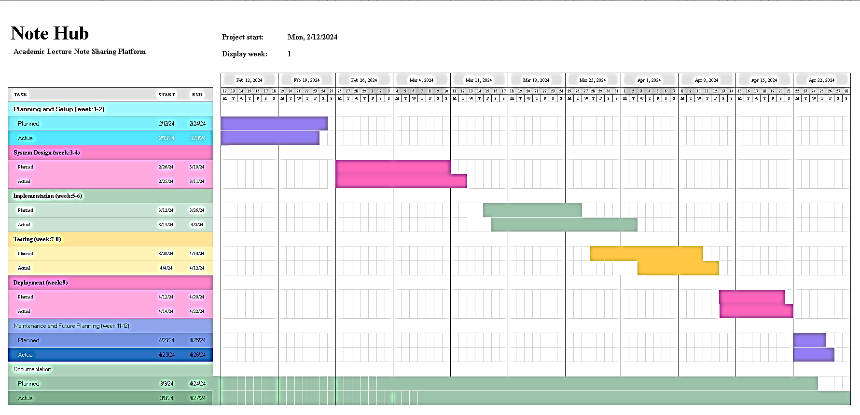

#### Figure 1: Gantt chart

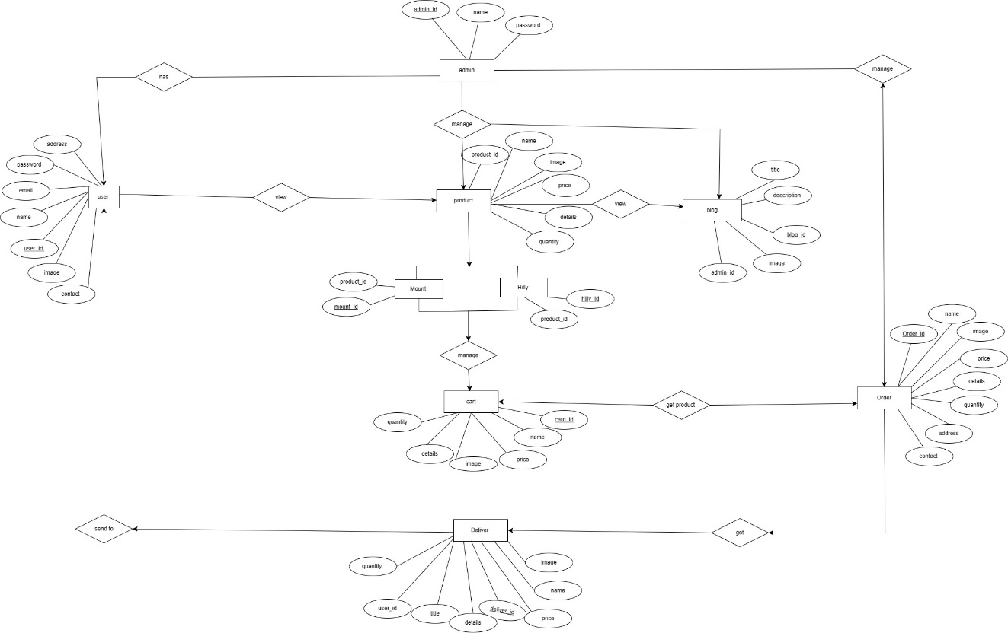**3.1.3. Data Modeling (ER Diagram)**

#### Figure 2: ER Diagram

**3.1.4. Process Modeling (DFD)**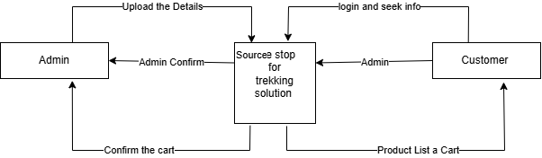

#### Figure 3: DFD Level 0

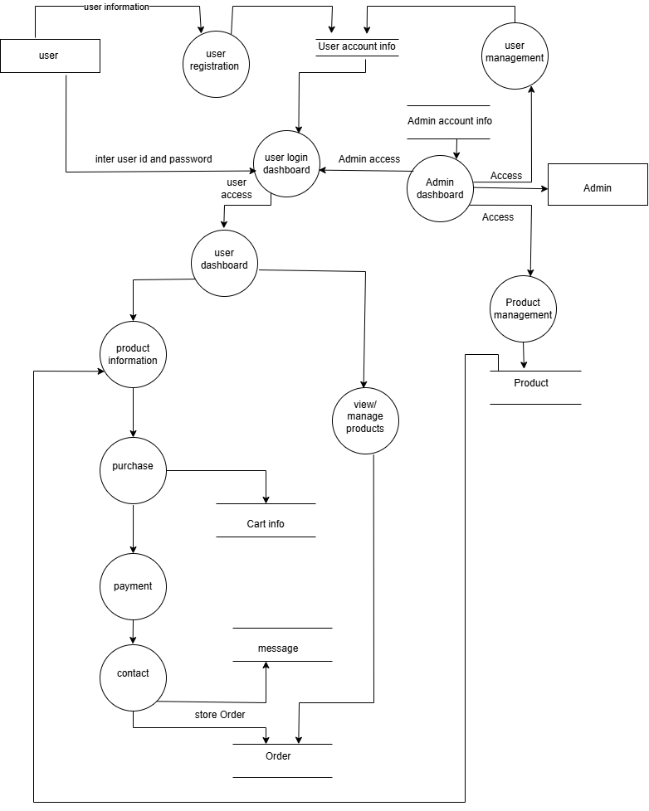

#### Figure 4: DFD Level 1

## 3.2 System Design

**3.2.1 Architectural Design**

Architectural design is a process for identifying the sub-systems making up a system and the framework for sub-system control and communication.

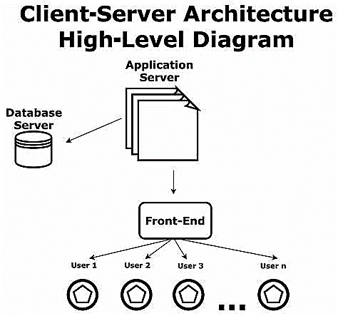For out One stopped trekking solution web application we will follow client server architecture.

#### Figure 5: Clint Server Architecture

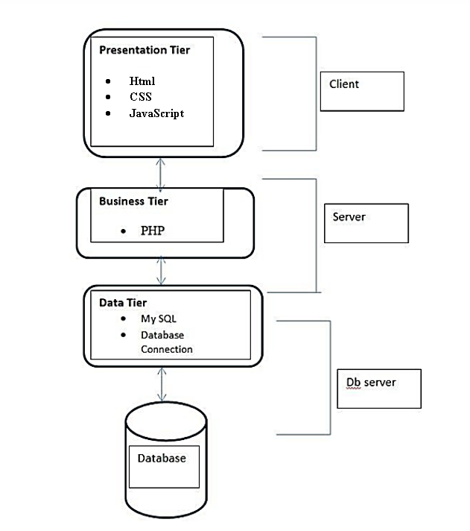

#### Figure 6: Architectural Design

**3.2.2 Database Schema Design**

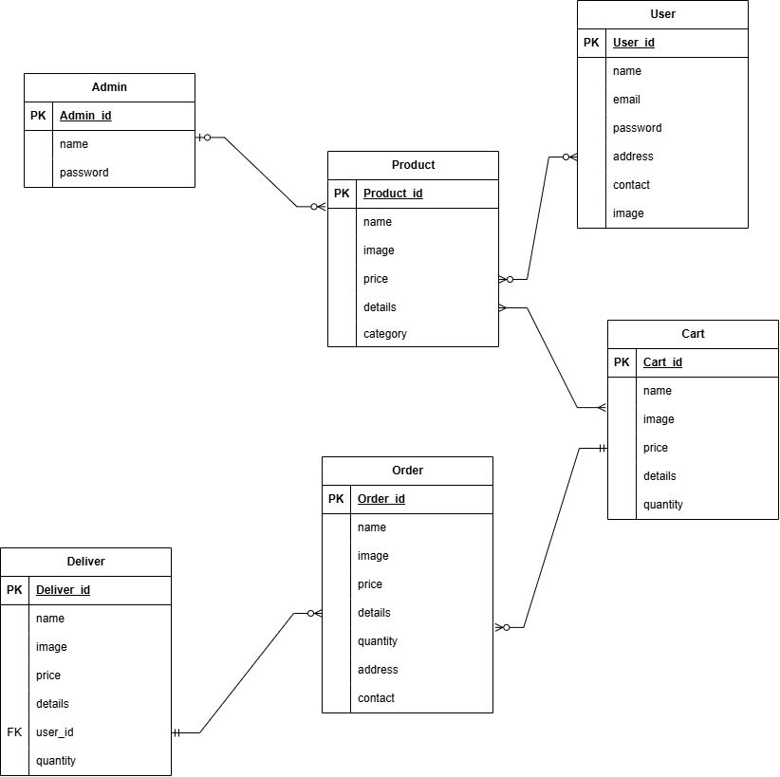

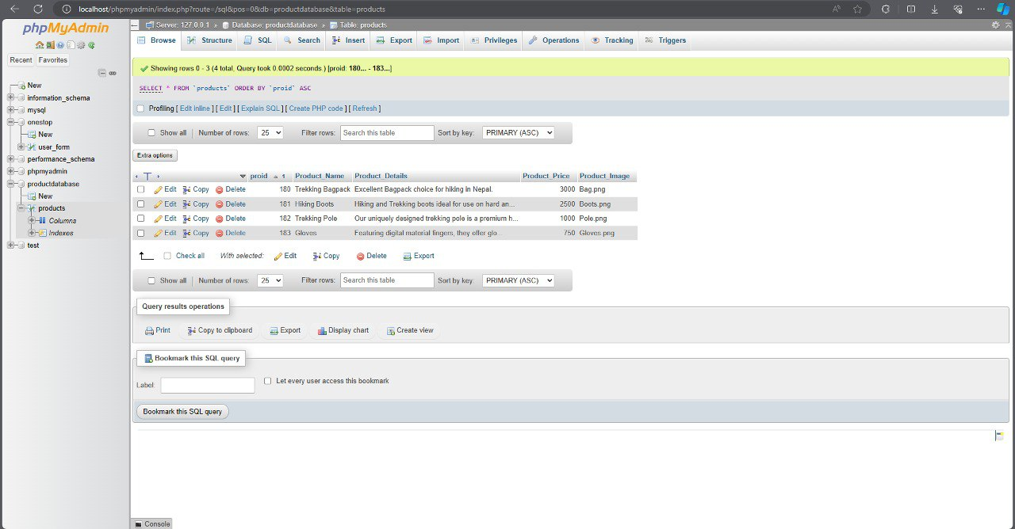

#### Figure 7: Database Schema

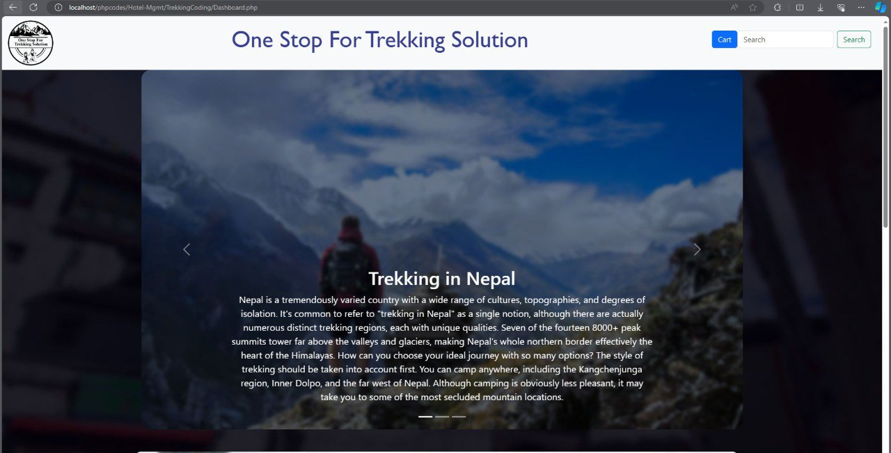

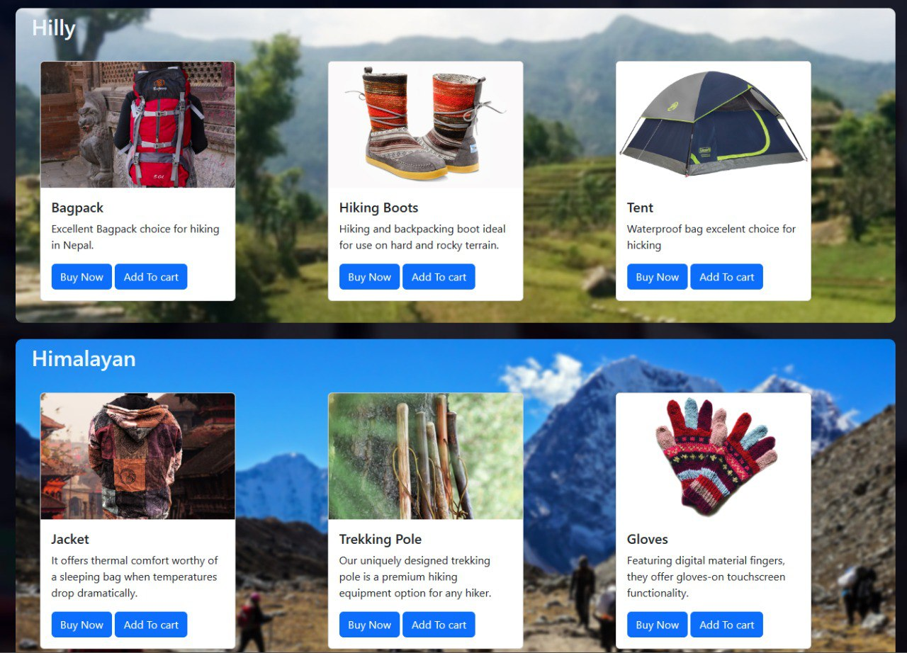

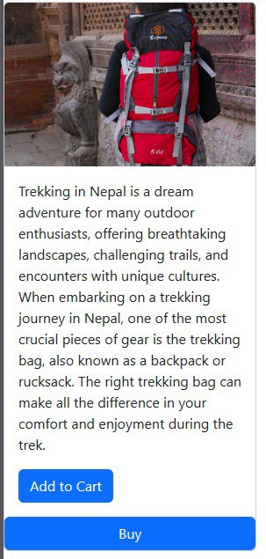

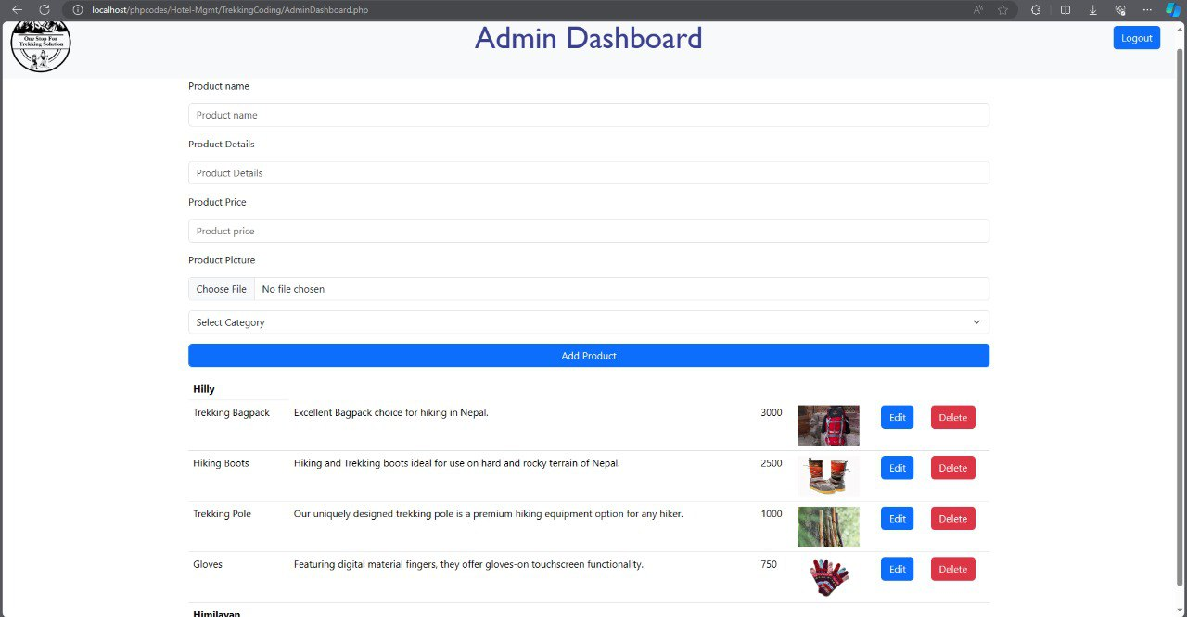

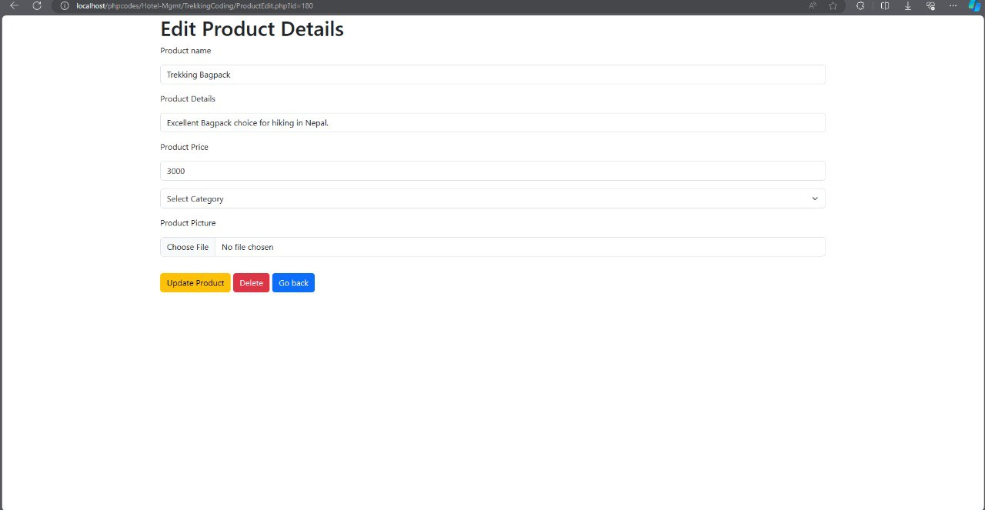

# Chapter 4: IMPLEMENTATION AND TESTING

## 4.1 Implementation

**4.1.1 Tools Used (CASE tools, Programming language, Database platforms**

Various tools were used during the development of this web-based applications which are explained below.

**Visual Studio:**

* Integrated Development Environment (IDE) developed by Microsoft.
* Features include code editing, debugging, version control integration, and project management tools.
* Supports various programming languages including C#, C++, Visual Basic, and more.

**Git:**

* Version control system for tracking changes in source code during software development.
* Allows branching, merging, and reverting changes easily.
* Facilitates collaborative development among multiple developers.

**GitHub:**

* Web-based platform for hosting Git repositories.
* Widely used for open-source projects and community-driven development
* Offers collaboration features such as pull requests and project management tools.

**HTML (Hypertext Markup Language):**

* A standard markup language for creating web pages and web applications.
* Defines the structure and content of web documents using tags and attributes.
* Supported by all web browsers and forms the backbone of the World Wide Web.

**CSS (Cascading Style Sheets):**

* Style sheet language used for describing the presentation of HTML documents.
* Controls the layout, appearance, and formatting of web pages.
* Allows separation of content from presentation, enabling easier site maintenance and design consistency.

**JavaScript:**

* High-level programming language primarily used for adding interactivity and dynamic behavior to web pages.
* Widely used for web development, including animations, form validation, and AJAX requests.
* Runs on the client-side within web browsers, enabling real-time updates and user interactions.

**jQuery:**

* Provides a concise syntax for common tasks such as DOM manipulation, event handling, and AJAX calls.
* Fast, lightweight JavaScript library designed to simplify client-side scripting.
* Compatible with various web browsers and simplifies cross-browser development.

**PHP (Hypertext Preprocessor):**

* Widely used for building e-commerce platforms, content management systems, and web-based applications.
* Server-side scripting language used for developing dynamic web applications and websites.
* Integrates seamlessly with HTML and can generate dynamic content on the server before sending it to the client's browser.

**MySQL:**

* Supports SQL (Structured Query Language) for managing databases, querying data, and performing database operations.
* Open-source relational database management system (RDBMS).
* Scalable and reliable, suitable for small to large-scale applications.

**SQL (Structured Query Language):**

* Standardized programming language for managing relational databases.
* Used for querying, updating, and managing data stored in databases.
* Common operations include SELECT, INSERT, UPDATE, DELETE, and JOIN.

**Apache:**

* Open-source web server software widely used for hosting websites and web applications.
* Configurable and extensible, with support for modules and plugins for additional functionality.

### 4.1.2 Implementation Details of Modules (Description of procedures/functions)

Here's an outline of the implementation details of the module for One stop for trekking solution web application.

1. **User Registration Module:**

Description: Manages user registration and input validation.

* Validation: Check if username and email are provided and validate email format.
* Email Check: Ensure email uniqueness by querying the database.
* Error Handling: Display validation errors to the user if any.
* Integration: Integrate validation with the registration form submission handler.
* Database Interaction: Query the users table to check for existing email addresses and insert new user records.

1. **User Login Module:**

Description: Manages user authentication and login functionality.

* Validation: Validate username and password inputs.
* Authentication: Verify credentials against database records.
* Session Management: Generate and store authentication tokens upon successful login.
* Integration: Integrate login functionality with the login form.
* Database Interaction: Query users table for authentication.

1. **User Profile Management Module**

Description: Manages user profiles, including viewing and editing.

* View Profile: Retrieve user profile information from the database.
* Edit Profile: Update user profile information in the database.
* Integration: Integrate profile viewing and editing with user interface.
* Database Interaction: Execute SQL queries to retrieve and update user profiles.

1. **Product Upload Module**

Description: Handles uploading of notes by admin.

* Upload Product: Save uploaded notes to the server and store metadata in the database.
* Integration: Integrate note upload functionality with admin interface.
* Database Interaction: Execute SQL queries to manage product uploads and metadata.

1. **Management Module**

Description: Manages Product.

* Display Product: Retrieve note data from the database based on product ID and display it in user dashboard.
* Rate Product: Record user ratings for products in the database.
* Delete Product: Remove product records from the database by admin.
* Database Interaction: Execute SQL queries to perform CRUD operations on products table.

## 4.2 Testing

### 4.2.1 Test Case for Unit Testing

Unit testing is achieved by conducting the following steps:

* Conduct the code execution steps.
* Identify and resolve any errors

# Chapter 5: CONCLUSION AND RECOMENDATION

## 5.1 Lesson Learnt/ Outcome

Throughout the development of this web based application various lessons have been learnt. Some of those lessons are shared below for future references.

* We learnt the basics of web development components such as HTML JavaScript, CSS, J-Query and get familiarized with its potentials and loopholes.
* We also familiarized our self with the power of backend data management via XAMPP application.
* We learnt to perform SQL operations for our database at backend.
* Had a hand on experience with the case tools and IDE's such as Visual studio code.
* Familiarized our self with version control systems such as Git and its counterpart github etc.
* Developing application in an environment with multiple developers and tracking all the changes and keeping the project synchronized throughout among the team.
* Keeping the project up-to-date as per the timeline.
* Full testing and verification of components and its correction before the deadline.
* By the end of this project we have been able to understand how software development system works from the ground up. From choosing appropriate development models to system analysis and design followed by implementation and testing

## 5.2 Conclusion

In conclusion, the target set for the development of “One Stop Trekking Solution” the initiative aims to promote and protect Nepal's cultural and ecological heritage through curated trekking experiences, support local communities and businesses, and enhance tourism by showcasing positive customer experiences and continuously improving based on feedback.

## 5.3 Future Recommendations

1. Interactive Route Mapping:

- Allow users to customize and share trekking routes.

- Include points of interest, difficulty levels, and estimated times.

2. Comprehensive Gear and Services Marketplace:

- Offer a marketplace for buying, renting, and reviewing trekking gear.

- Enable booking of services like guides, porters, and accommodations.

3. Community Engagement and Feedback:

- Facilitate sharing of trekking experiences, photos, and videos.

- Implement features for rating trails and services.

- Encourage discussions to foster community and gather insights for improvement.

## Reference

[1] Ghimire, S., & Shakya, S. (2020). "Impact of E-Commerce on Local Product Promotion: A Case Study of Nepal." Journal of International Business Research and Marketing, 5(1), 23-28.

[2] Government of Nepal. (2019). "National Strategy for Promotion of Micro, Small, and Cottage Industries in Nepal." Ministry of Industry, Commerce, and Supplies.

[3] Karki, R., & Shrestha, P. (2018). "Role of E-commerce in Promoting Nepalese Handicrafts: A Study on Social Media and Online Shopping Platforms." International Journal of Scientific and Research Publications, 8(11), 473-478.

[4] Pant, R., & Pokharel, B. (2017). "Promotion of Local Products through E-commerce in Nepal: A Study on Opportunities and Challenges." Journal of Business and Social Sciences Research, 2(1), 12-19.

[5] Pokharel, A. (2019). "Role of Digital Marketing in Promoting Nepali Handicrafts: A Case Study of Selected Handicraft Businesses in Kathmandu Valley." Nepal Journal of

Business, 6(1), 25-35.